# Air Pollution from Transport

**Air Quality**

Air pollutants from transport include nitrogen oxides, particles, carbon monoxide and hydrocarbons. All have a damaging impact on the health of people, animals and vegetation locally. Air quality in the UK is slowly improving, but many areas still fail to meet the health based national air quality objectives and European limit values – particularly for particles and nitrogen dioxide. In town centres and alongside busy roads, vehicles are responsible for most local pollution. Vehicles tend to emit more pollution during the first few miles of journey when their engines are warming up. Although new technology and cleaner fuel formulations will continue to cut emissions of pollutants, the increasing number of vehicles on the road and miles driven is eroding these benefits.[1]

**Different Pollutants from Vehicles[2]**

**CO:** Carbon monoxide reduces the blood’s oxygen-carrying capacity which can reduce the availability of oxygen to key organs. Extreme levels of exposure, such as might occur due to blocked flues in domestic boilers, can be fatal. At lower concentrations CO may pose a health risk, particularly to those suffering from heart disease.

**NOx:** also contributes to smog formation, and acid rain, can damage vegetation, contributes to ground-level ozone formation and can react in the atmosphere to form fine particles

Particulate matter: **PM:** Particulate matter is associated with respiratory and cardiovascular problem. 29,000 deaths a year in the UK are attributable to fine particulate pollution.

**HC:** Hydrocarbons contribute to ground-level ozone formation leading to risk of damage to the human respiratory system. Some kinds of hydrocarbons, in addition, are both carcinogenic and indirect greenhouse gases.

**List of facts about air pollution[3],[4]**

* Inhaling air pollution takes away at least 1-2 years of a typical human life.
* It has effects as small as burning eyes and itchy throat to as large as breathing problems and death.
* Deaths caused by air pollution cost the European Union €161 billion.
* According to the Lancet journal, air pollution caused by waiting in traffic increases the chances of death caused due to heart attack.
* 65% of the deaths in Asia and 25% deaths in India are due to air pollution.
* 80% of lung diseases are caused due to pollution from other cars, buses, trucks and other vehicles.
* Research by MIT proves that around 13,000 British citizens die due to air pollution from vehicles and power plants.
* By 2050, 6 million people will die per year due to air pollution.
* During heavy traffic jam, pollutants outside can seep into your car, making the air inside you car 10 times more polluted than typical city air.
* Indoor air pollution is 2-5 times worse than the air outdoors.
* People who live near high traffic roads face greater risk of cancer, heart disease, asthma and bronchitis as these places contain more concentrated levels of air pollution.
* Nearly 50% of pneumonia deaths among children under five are due to particulate matter inhaled from indoor air pollution.
* More than 1 million people a year die from chronic obstructive respiratory disease (COPD) that develop due to exposure to such indoor air pollution.
* In urban areas, harmful automotive emissions are responsible for anywhere between 50 and 90 percent of air pollution.[5]
* Traffic pollution is estimated to kill up to 5000 people a year in the UK alone.[6]

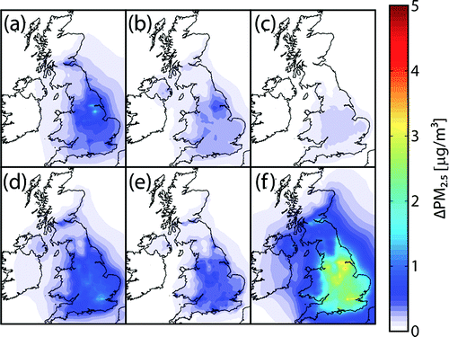

(Above:)Annual average PM2.5 concentration due to combustion emissions from (a) power generation; (b) commercial, institutional, residential, and agricultural sources; (c) industry; (d) road transport; (e) other transport; and (f) all UK combustion sources.[7]

1. <http://www.environmental-protection.org.uk/committees/air-quality/air-pollution-and-transport/car-pollution/>
2. <http://www.dft.gov.uk/vca/fcb/cars-and-air-pollution.asp>
3. <http://www.conserve-energy-future.com/various-air-pollution-facts.php>
4. <http://eschooltoday.com/pollution/air-pollution/air-pollution-facts.html>
5. <http://auto.howstuffworks.com/percentage-of-air-pollution-due-to-cars.htm>
6. <http://www.bbc.co.uk/news/science-environment-17704116>
7. <http://pubs.acs.org/doi/abs/10.1021/es2040416>